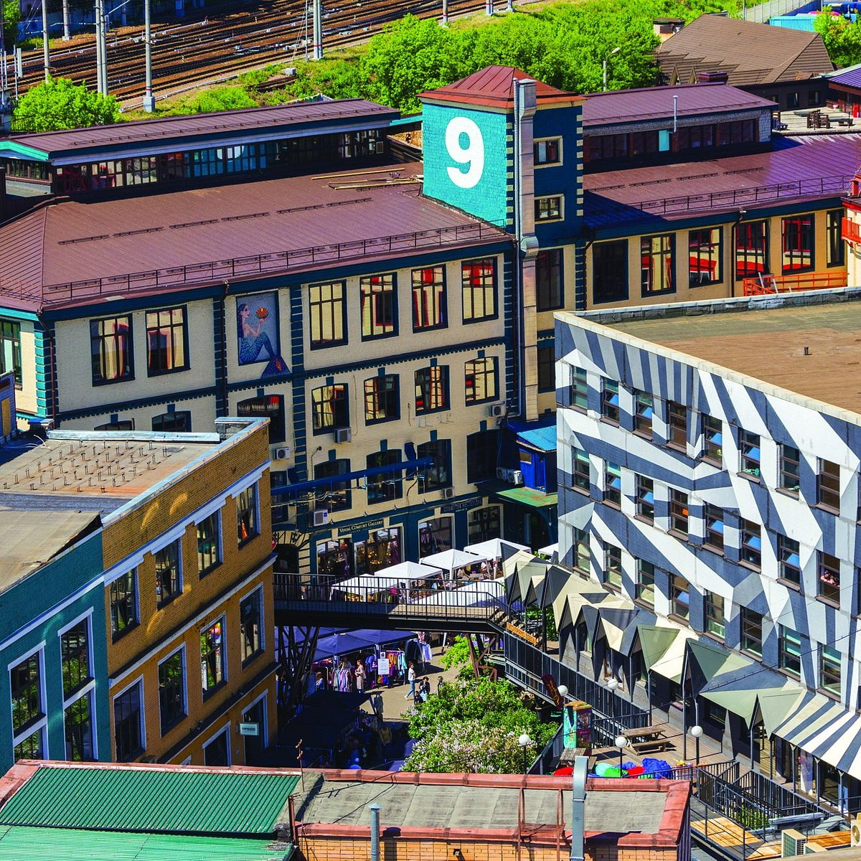

**Design center “Artplay”**

Exhibitions, performances, lectures, design and architecture studios, shops – whole quarter for creative work and leisure.

Working hours: 10:00 – 21:00 every day

Address: st. Nizhnyaya Syromyatnicheskaya 10, building 7

Webpage: <https://m.artplay.ru/>

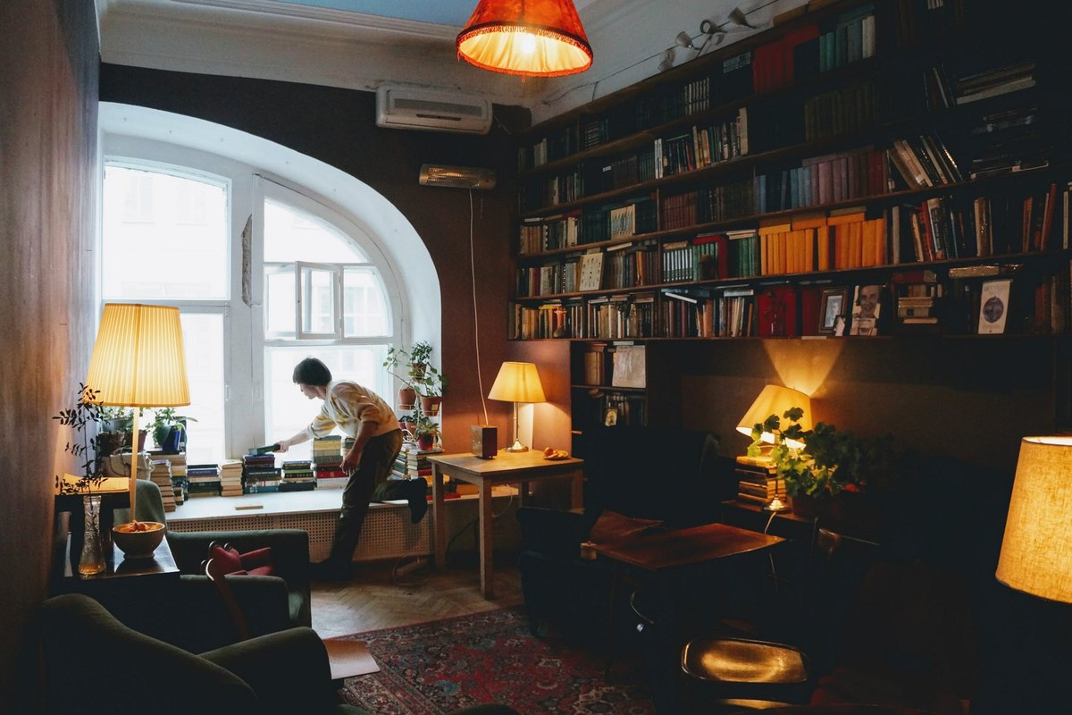

**Anticafé “Ziferblat”**

Truly legendary anticafé in Moscow. Visitors play board games, learn foreign languages, hold live concerts and creative meetings. Person pays only for time spent here. “Everything is free except for the minutes, “ as they say.

Working hours: 24/7

Address: st. Kuznetsky Most 19, building 1

Webpage: <https://ziferblat.net/>

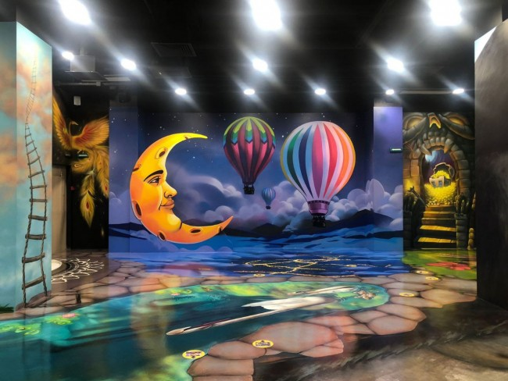

**Museum of Optical Illusion**

The format of this interactive museum involves photography and visitors become part of the installations. Prepare to not trust your own eyes and welcome!

Working hours: 10:00 – 21:00 every day

Address: Prospekt Mira 119 (VDNKh, pavilion 55)

Webpage: <https://vdnh.ru/places/pavilon-55-elektrifikatsiya-zhivotnovodstvo-/>

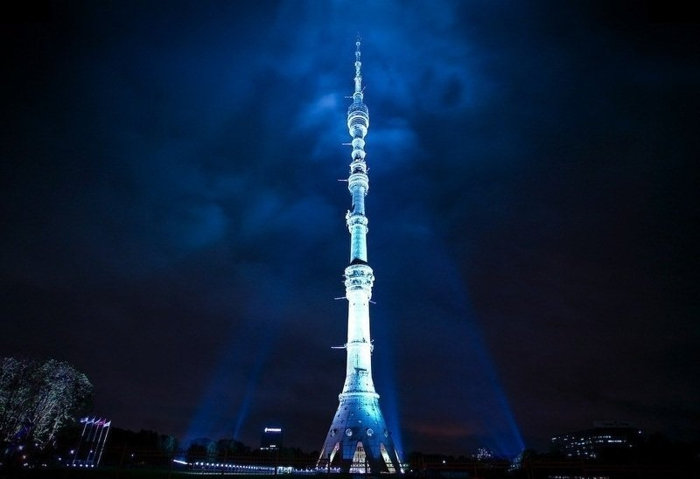

**Ostankino Tower**

One of the highest buildings in the world and one of the most visited tourist attractions. You don’t want to miss this. But be ready to pay relatively high fee. Especially if you want to have a meal with an incredible view of Moscow.

Working hours: 10:00 – 23:00 every day

Address: Academic Korolev Street 15w2

Webpage: <https://tvtower.ru/en/>

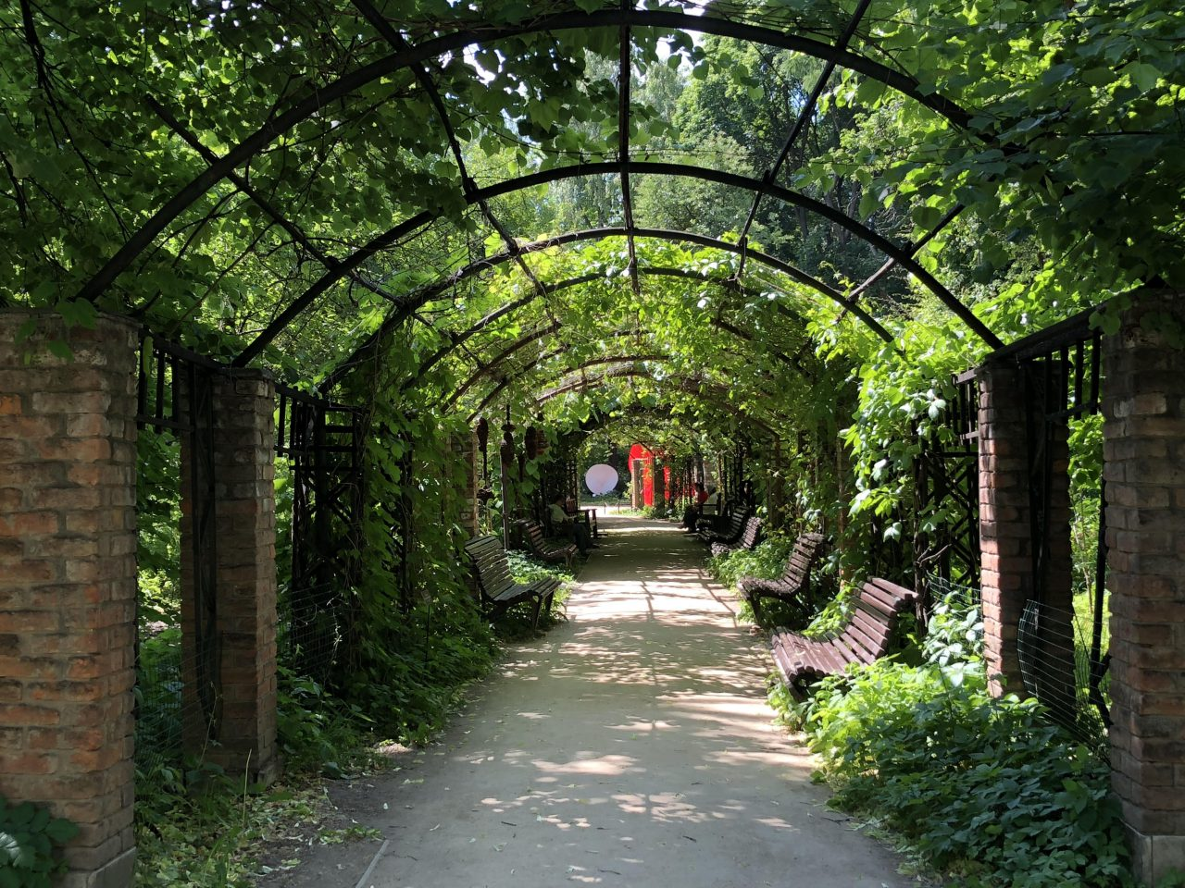

**Aptekarsky Garden**

Evergreen piece of land in urban environment, fascinating flower patterns, rare plants. And the most important thing – best pirozhki in Moscow.

Working hours: 10:00 – 20:00 every day

Address: Prospekt Mira 26 building 1

Webpage: <https://hortus.msu.ru/>

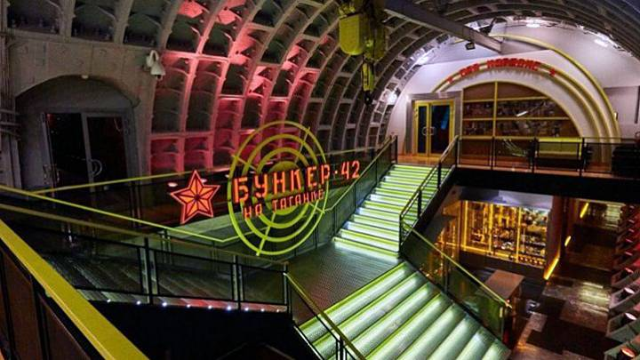

**Museum of the Cold War “Bunker-42”**

“Bunker-42” is located in the centre of Moscow at a depth of 65 meters. It features formerly classified documents.

Working hours: 24/7

Address: 5th Kotelnicheskiy Line 11

Webpage: <https://bunker42.com/>

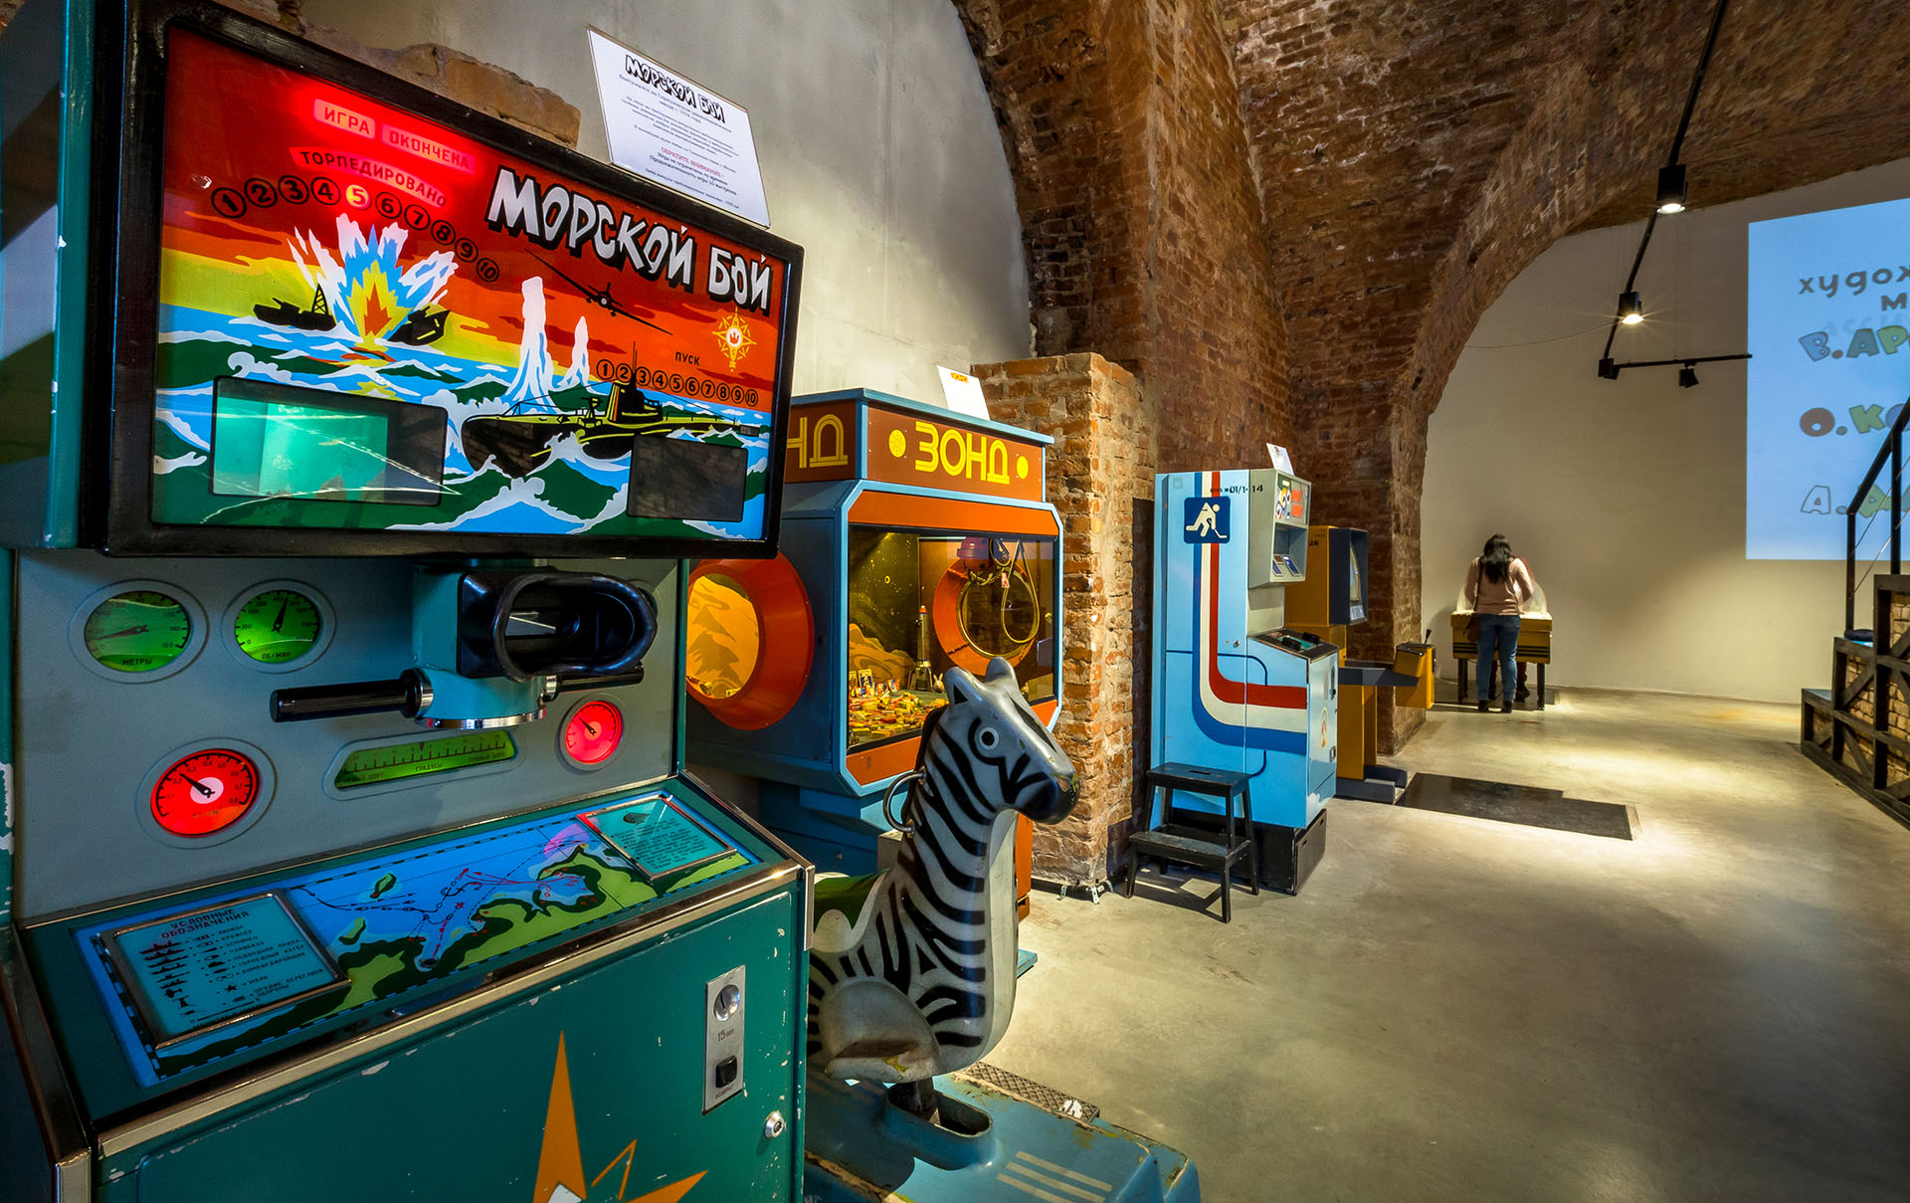

**Museum of Soviet Gaming Machines**

Here you will find the most famous slot machines many of which are preserved in a single copy. And in between games you can eat an ice cream and drink soda. After all, everyone wants to be an adult child sometimes.

Working hours: 11:00-21:00 every day

Address: Prospekt Mira 119 building 57

Webpage: <https://15kop.ru/>

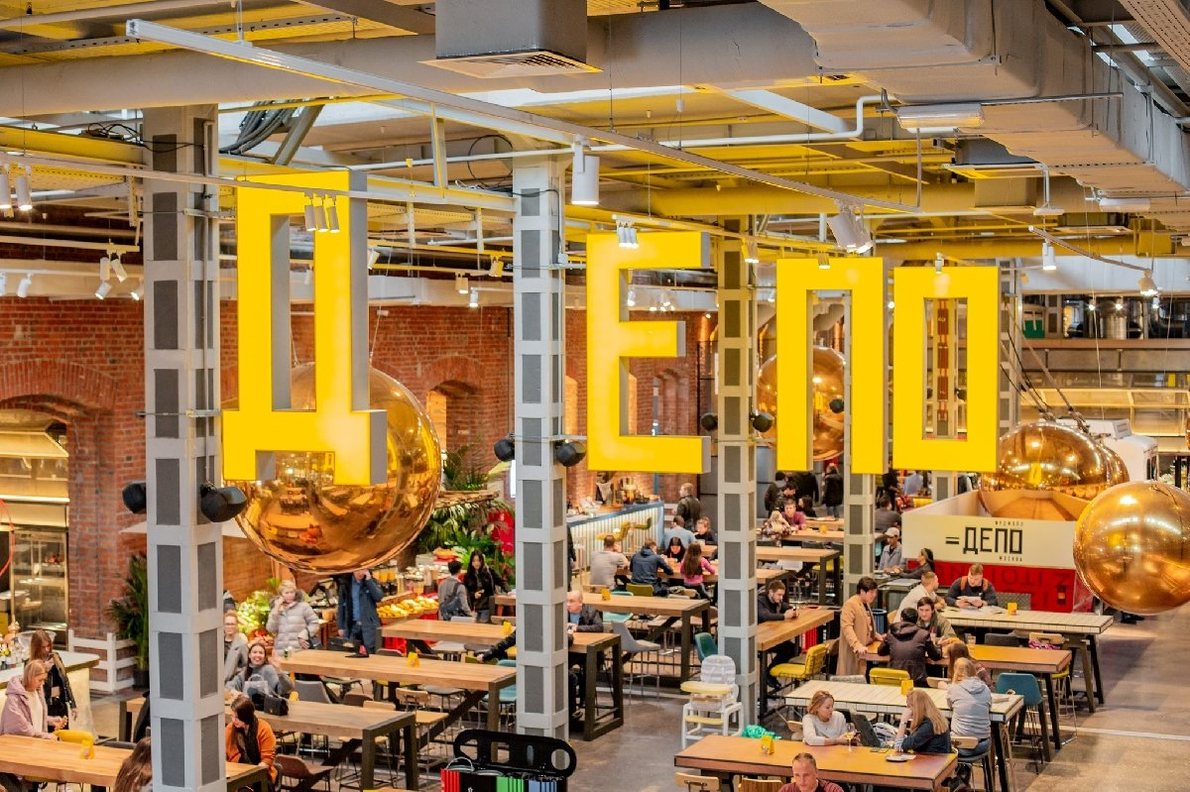

**Foodmall “Depo. Moscow”**

The biggest foodmall in Europe featuring 75 restaurant-like booths and 60 booths with farmer produce.

Working hours: Monday to Thursday and Sunday 10:00 – 23:00, Friday and Saturday 10:00 – 02:00

Address: Lesnaya Street 20 building 3

Webpage: <https://depomoscow.ru/>

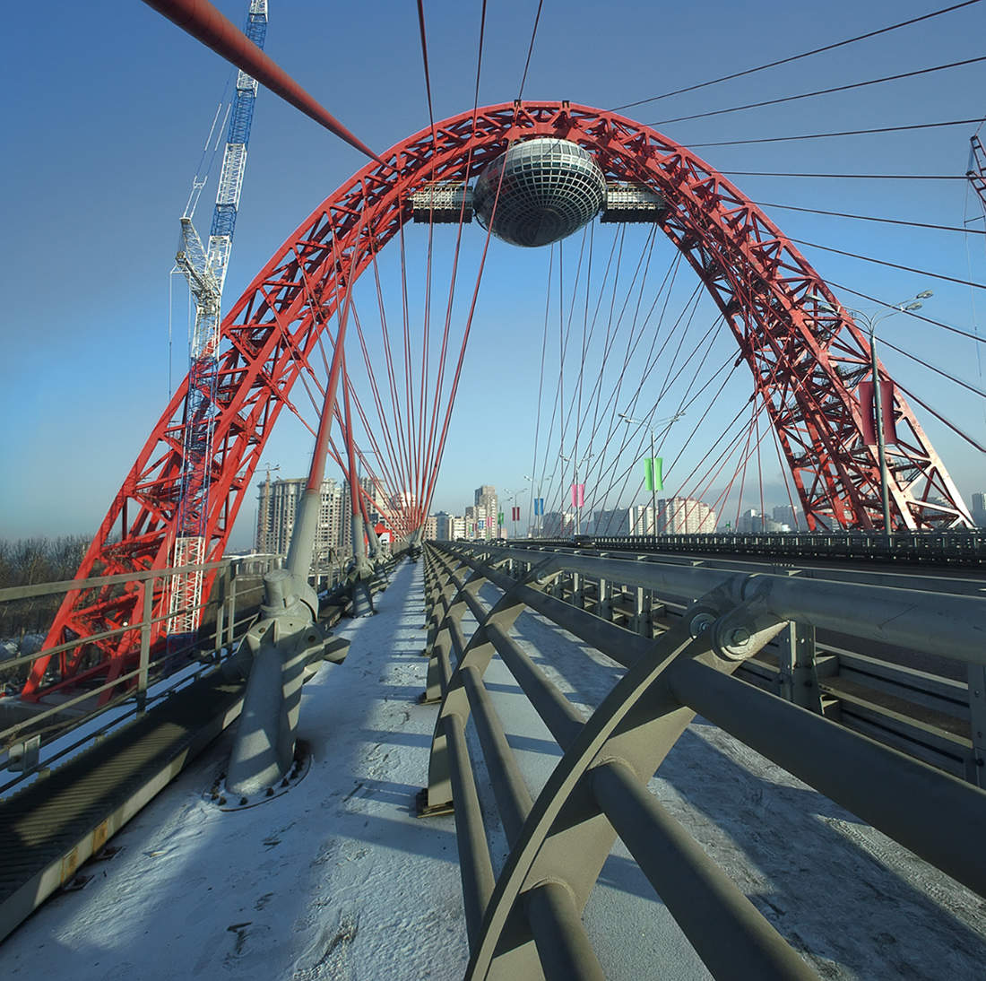

**Cableway Picturesque Bridge**

Built in 2007 this bridge immediately gained fame as an extraordinary symbol of Moscow. Obviously you can visit it anytime but evening is the best time for this.

Address: Krasnopresnenskiy Prospekt

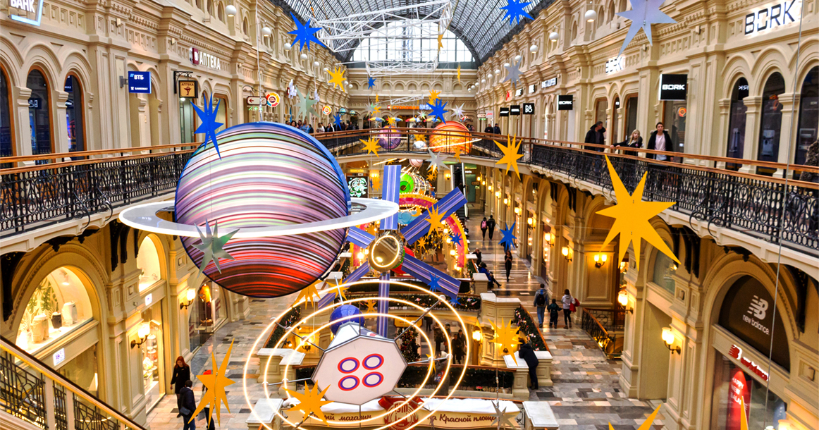

**GUM**

GUM or State Department Store is definitely worth visiting even if you don’t want to buy anything. You just wander here and there and wonder how beautiful this building is.

Working hours: 10:00 – 22:00 every day

Address: Red Square 3

Webpage: <https://gum.ru/>

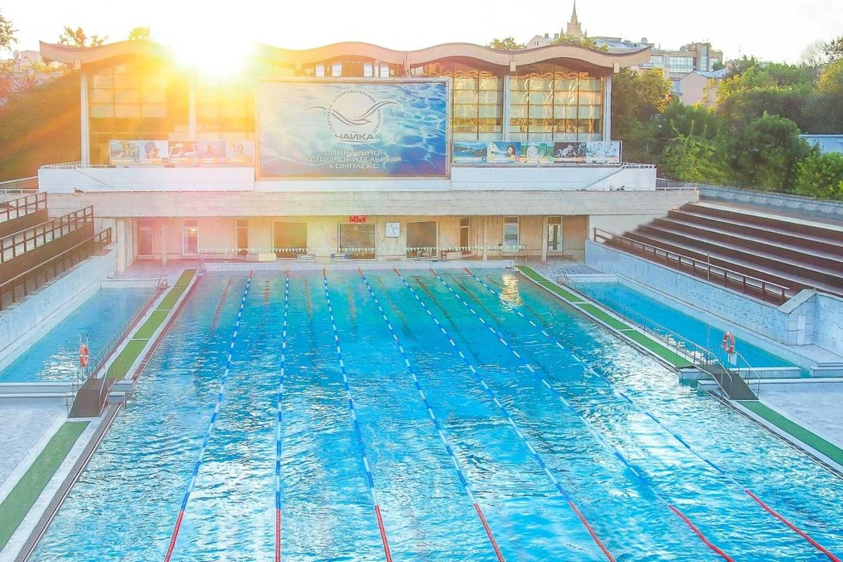

**“Chaika” Pool**

“Chaika” is one of the most popular modern open-air pools in the center of Moscow.

Working hours: Monday to Saturday 7:00 – 22:45, Sunday 8:00 – 20:45

Address: Turchaninov Line 3/1

Webpage: <https://www.chayka-sport.ru/>

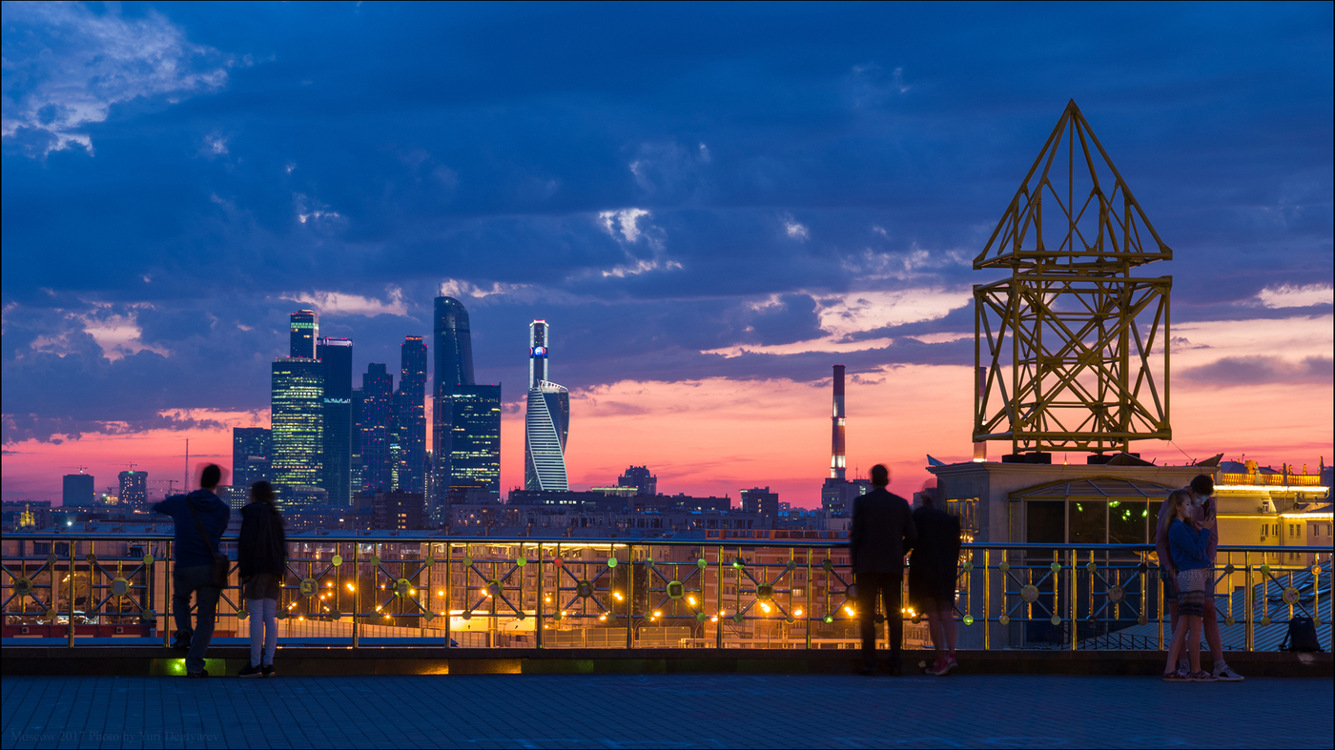

**RAN Viewpoint**

The site offers a fascinating view of Moscow and its sights.

Working hours: 24/7

Address: Leninskiy Prospekt 32A, building 1

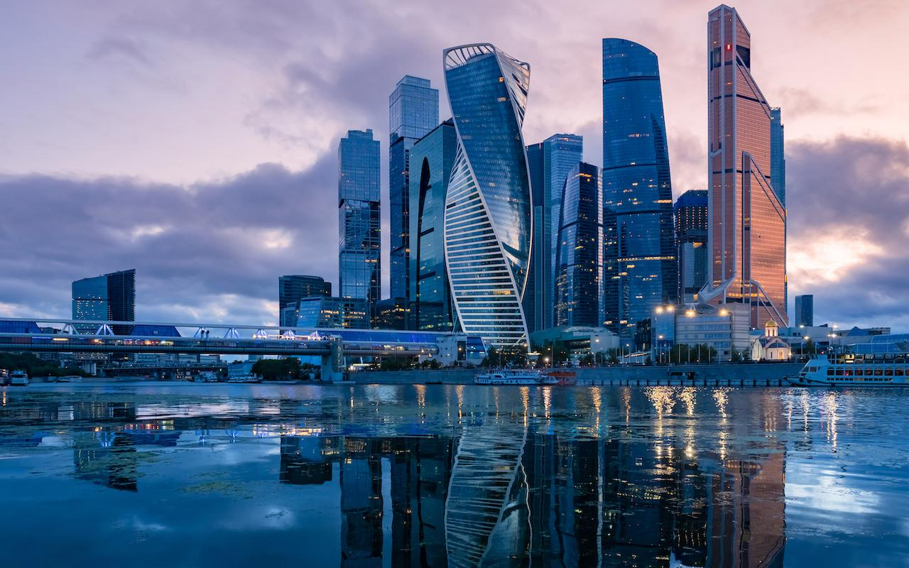

**Moscow City**

“City of Capitals”, “Central Core”, “Mercury City Tower” – grand skyscraper complex in Moscow City business district is growing year on year.

Working hours: 10:00 – 22:00 every day

Address: Presnenskay Promenade (metro station “Vystovachnaya”)

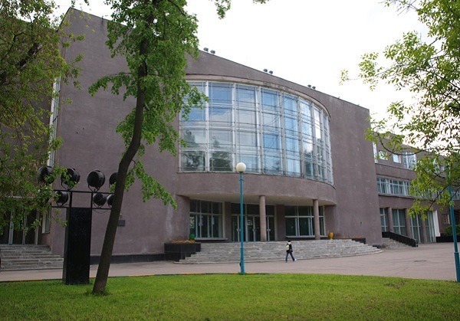

**ZIL Cultural Centre**

ZIL is the largest palace of culture in the capital, a multifunctional space with a large number of tourist attractions. Every day there are plays, concerts, performances, festivals, lectures, master classes, events for children and exhibitions.

Working hours: 10:00 – 22:00 every day

Address: Vostochnaya Street 4

Webpage: <https://zilcc.ru/>

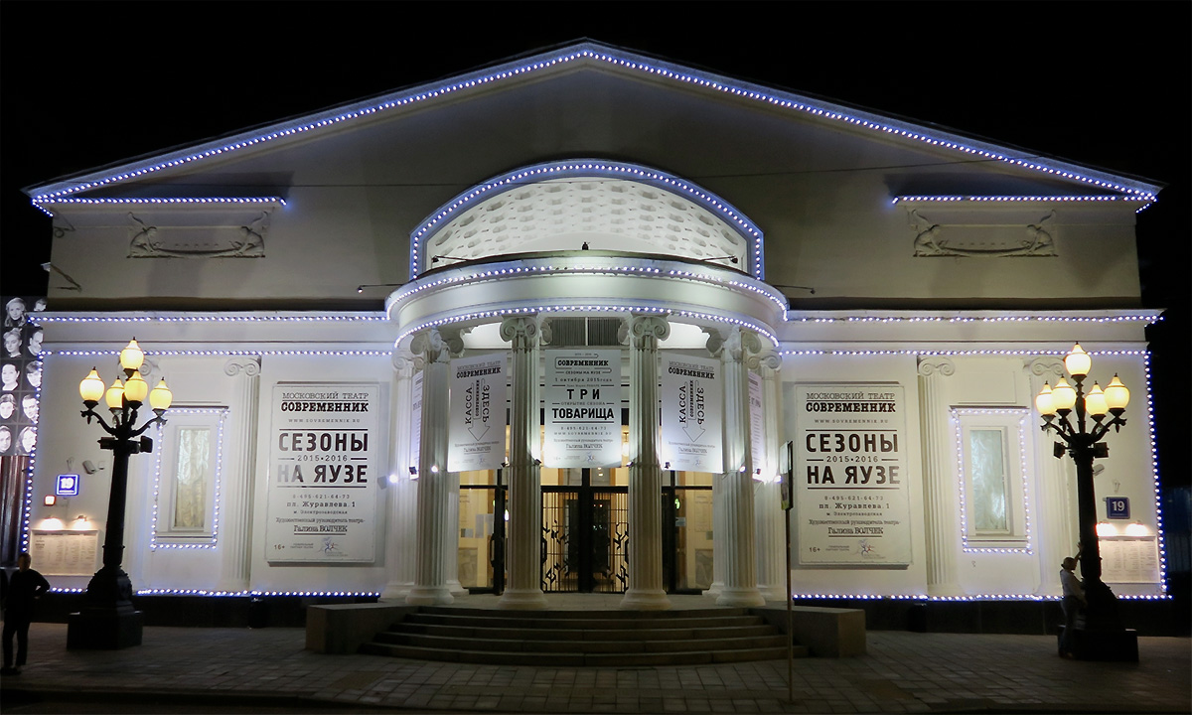

**The Sovremennik Theatre**

Over the years, the Sovremennik Theater has presented the world with many talented actors and has become one of the most iconic in the history of Russian culture.

Address: Chistoprudniy Boulevard 19

Webpage: <https://sovremennik.ru/>

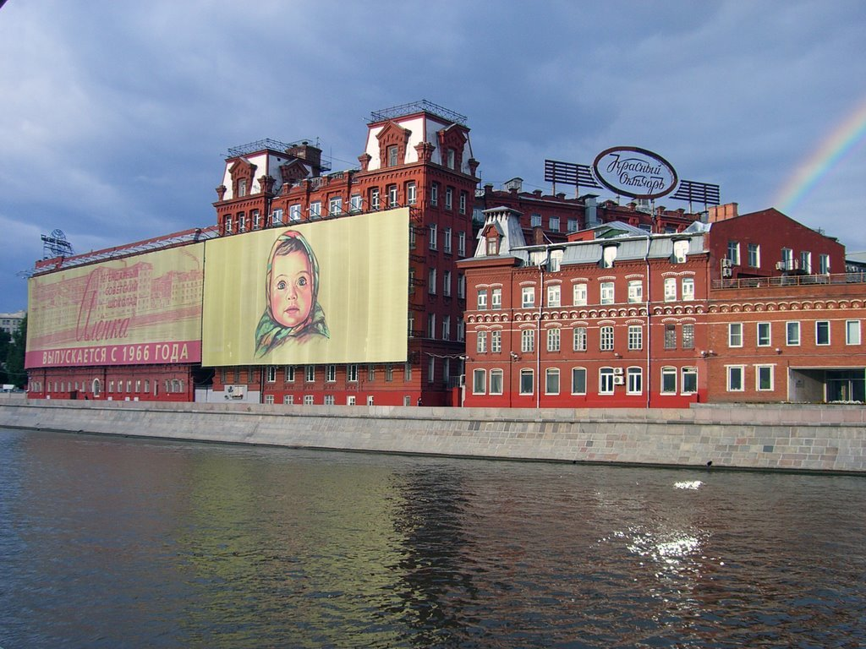

**“Red October” Factory**

Once – the biggest Soviet confectionery factory, now – one of the biggest art spaces in Moscow.

Working hours: 24/7

Address: Bersenevskay Promenade 6